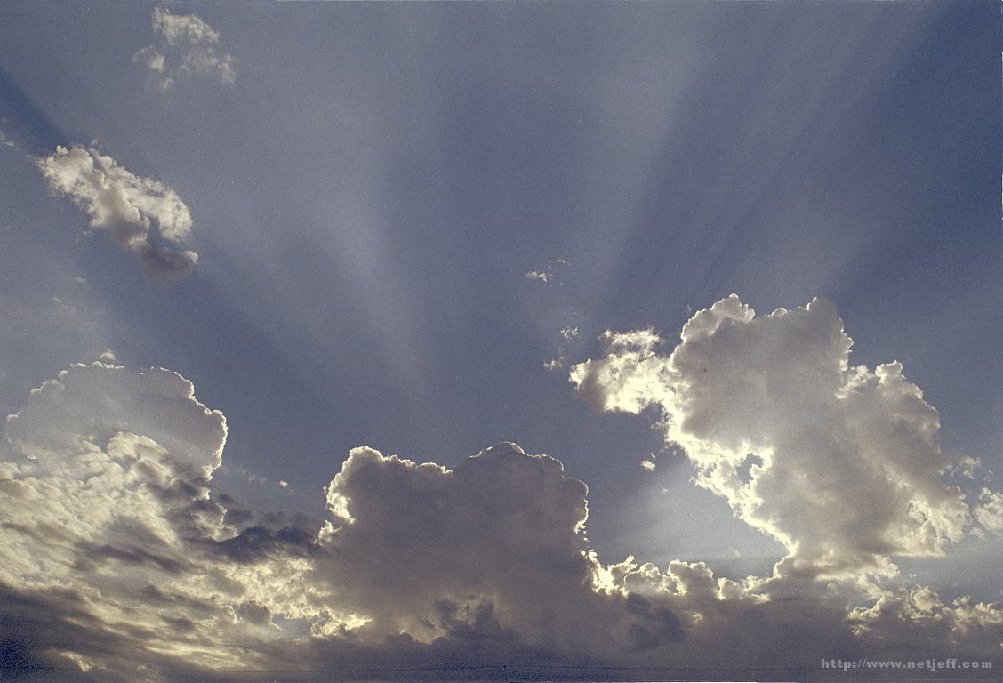All good gifts come from above and I’m thankful. (repeat)

My heavenly Father gives the best.

1

I don’t need to have

the rest.

christmas 15All good gifts come from above and I’m thankful.

2.

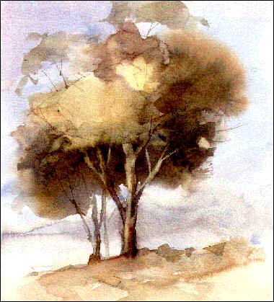For fruits and vegetables, meat and cheese, I’m thankful.

For sunny days and flowers and trees, I’m thankful.

3.

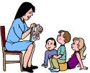For family, friends, and teachers too.

Even lessons learned in school.

All good gifts come from above and I’m thankful.

4.